WALEED HAMED, as the Executor of the Estate of MOHAMMAD HAMED, | Case No.: SX-2012-CV-370
Plaintiff/Counterclaim Defendant,
vs.  FATHI YUSUF and UNITED CORPORATION | ACTION FOR DAMAGES, INJUNCTIVE RELIEF AND DECLARATORY RELIEF
Defendants and Counterclaimants.  vs.  WALEED HAMED, WAHEED HAMED, MUFEED HAMED, HISHAM HAMED, and PLESSEN ENTERPRISES, INC.,  Counterclaim Defendants, | JURY TRIAL DEMANDED
 | Consolidated with
WALEED HAMED, as the Executor of the Estate of MOHAMMAD HAMED, Plaintiff,  vs. | Case No.: SX-2014-CV-287
UNITED CORPORATION, Defendant.
WALEED HAMED, as the Executor of the Estate of MOHAMMAD HAMED, Plaintiff  vs.  FATHI YUSUF, Defendant. | Consolidated with  Case No.: SX-2014-CV-278
FATHI YUSUF, Plaintiff,  vs.  MOHAMMAD A. HAMED TRUST, et al,  Defendants. | Consolidated with  Case No.: ST-17-CV-384
KAC357 Inc., Plaintiff,  vs.  HAMED/YUSUF PARTNERSHIP,  Defendant. | Consolidated with  Case No.: ST-18-CV-219

HAMED’S MOTION FOR PARTIAL SUMMARY JUDGMENT

RE A PORTION OF REVISED CLAIM H-141 – $1.5 MILLION CHECK TO YUSUF
- Introduction

This final Hamed “B” claim (H-151) is comprised of three sub-issues: (1) a check for $1.5 million, known to have been withdrawn solely by Fathi Yusuf and used for a personal gift to his daughter Hoda and her husband, (2) a second check for $1.5 million, known to have been withdrawn by Fathi Yusuf and used for a personal gift to his other daughter and her husband, and (2) a series of checks taken from Partnership accounts by Fathi Yusuf—regarding which it has been nearly impossible to obtain an accurate accounting because of his obfuscations of discovery response—a motion for contempt is pending, which is why this remains a motion for a partial summary judgment despite the late date.

This motion deals with the first item—the withdrawal of $1.5 million in Partnership funds by Fathi Yusuf—which he and his wife then, solely, gave to Hoda Yusuf Hamed and her husband Hisham Hamed. Below are the two checks at issue here:

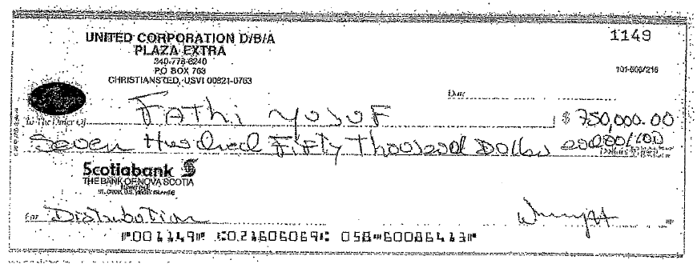

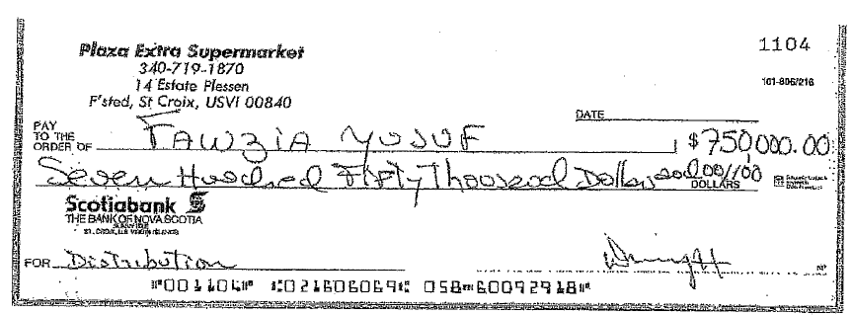

It is undisputed that as one of the two partners, Fathi Yusuf withdrew the amount of $1.5 million from Partnership accounts via these checks. It is undisputed that he and his wife, Fawzia, each then wrote a letter reciting a personal gift of $750,000 from each of them—totaling $1.5 million. Exhibit 1 (Fathi) and Exhibit 2 (Fawzia).

Because the spouses of his daughters were both Hameds, normally this sort of gift might be ignored in an accounting—by custom, if not by legal mandate. However, when Fathi’s daughter Hoda was in divorce proceedings with Hisham Hamed, she asserted that Yusuf’s gift had been to her solely. More importantly, as can be seen in her motion to intervene that follows, she made property claims on that family home based on this position, Finally, she obtained possession of the family home in the favorable divorce settlement based on this position.

Thus, in 2016, while those divorce proceedings were ongoing, Hamed made his H-151 claim for those funds that Hoda stated were a personal gift from her father to her—and received the benefit of that claim once already.

Yusuf has previously argued that the unilateral withdrawal of these funds by him was of no consequence because Mohammad knew of, Wally signed, and Hisham endorsed the checks. He maintains that this means that “the Hameds KNEW” about the transfer. See February 22, 2002 Yusuf Opposition to the Motion to Compel, at 5. There Yusuf also tried to ignore the issue of who drew and spent the funds, and tried to cover up the joint attempt by him and his daughter to block the bond motion through his tactical activities in her divorce. He incredibly states:

Yusuf is unaware as to how these funds were treated in the divorce proceedings of one of his daughters. These are all of the documents of which Yusuf is aware relating to these withdrawals. There is no further need to compel any information as Yusuf has properly and adequately responded to same.

He makes this claim despite the fact that his own lawyers filed a motion frantically supporting Hoda’s divorce positions, in detail, in this action—on March 12, 2014—attaching Hoda’s motion to intervene and stating:

While the Opposition points out that on February 25, 2014, the Supreme Court dismissed Ms. Hamed's appeal [in her divorce proceedings] for failure to pay the docketing fee, on that same day, Ms. Hamed file a Motion to Set Aside Order of Dismissal. See Exhibit 2.

On February 28, 2014, Ms. Hamed filed a Reply to Appellee's Opposition to Motion to Set Aside Order of Dismissal [in her divorce proceedings], which further explained why the Order of Dismissal should be set aside and Ms. Hamed's interest in Plot 100. See Exhibit 3.

Regardless of whether Ms. Hamed' s appeal [in her divorce proceedings] is reinstated or whether this Court or the Family Court decides to discharge the Notice of Lis Pendens, given Ms. Hamed's claims of interest in and to Plot 100, no reputable title insurer would insure title to Plot I 00, without exceptions, under these circumstances. Accordingly, because Ms. Hamed's claims against Plot 100, including the claims evidenced by her undischarged Notice of Lis Pendens, "cause confusion or present uncertainty regarding 'how much ... money will remain once the ... proceedings have concluded,' ... [this] asset[] ... [is] insufficient for the purpose of satisfying an injunction bond." See this Court's order of January 15, 2014 at p. 5 (quoting from Yusuf v. Hamed, Civ. No. 2013-0040, 2013 WL 5429498, at* 9 (V.I. Sept. 30, 2013)). Because the undischarged Notice of Lis Pendens recorded against Plot 100 and Ms. Hamed' s asserted claims against Parcel 100 cause such confusion and uncertainty, Defendants respectfully submit that Parcel I00 cannot serve as security for the injunction bond and that Plaintiff must be required to immediately post cash or other encumbered property determined satisfactory by this Court. (Emphasis added.)

STATEMENT OF FACTS NOT IN DISPUTE
- At the time of the submission of the claims in this action, September 30, 2016, Hamed made (original) Claim 3004a—which is now part of H-151 based on the Special Master’s order.

Claim Item 3004a - Checks written to Fathi Yusuf

Summary Description of Issue identified:- Checks written from Partnership to Fathi Yusuf for personal use.

Work performed: We requested canceled checks for the Plaza Extra bank accounts. John Gaffney informed us that he does not have all of the canceled checks for each of the Plaza Extra bank accounts. . . .

- The two operative checks are shown above—thus, it is also uncontested that Fathi Yusuf, alone, withdrew $1.5 million from Partnership accounts.
- The evidentiary record reflects there are no commensurate withdrawals by, or gifts from Hamed, nor are any alleged by Yusuf.
- Exhibits 1 and 2 show that Fathi, alone, gave the $1.5 million as a gift.
- Hamed does not allege that he did not know of this withdrawal.
- Hamed does not allege that Hisham did not negotiate the checks gifted—but has asserted that Hoda later successfully asserted that these were her funds alone.
- In a pleading in this action, filed here by Fathi’s daughter, Hoda, she sets out the history and unilateral nature of the withdrawal and gift. She makes it clear that the gift was from Fathi and his wife alone. The following are the relevant portions of her March 12, 2914 Motion to Intervene in this action.
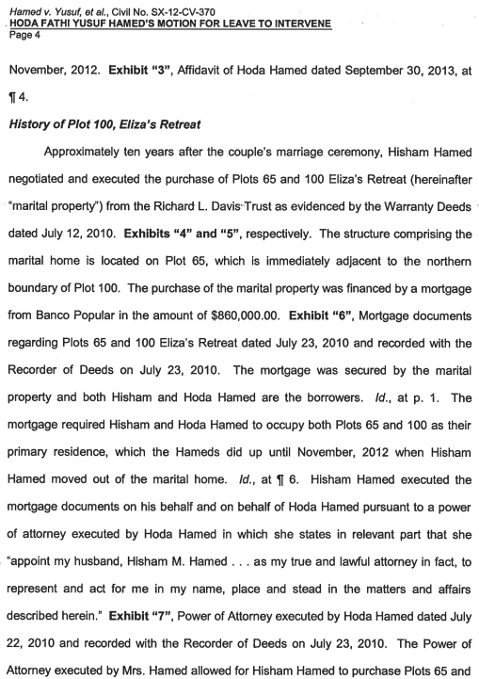
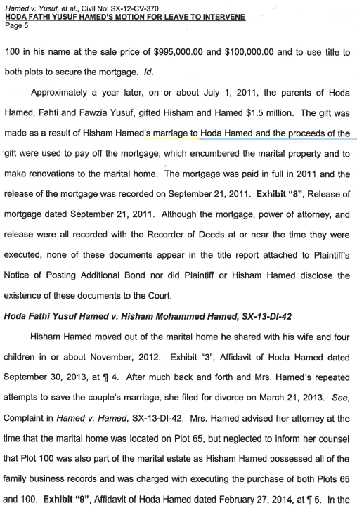

- Thus, the stated purpose of Hoda’s intervention in this case was to support Fathi Yusuf’s claims against Hisham and the Hameds, and to assist the Yusuf family in taking the Hamed half of the Plaza Extra Supermarkets by denying them the ability to post bond.
- Law

The Special Master has repeatedly set forth the applicable standard. Rule 56 of Virgin Islands Rules of Civil Procedure (hereinafter “Rule 56”) governs motions for summary judgment and sets forth the procedures thereto. Under Rule 56, “[a] party may move for summary judgment, identifying each claim or defense – or the part of each claim or defense – on which summary judgment is sought” and “[t]he court shall grant summary judgment if the movant shows that there is no genuine dispute as to any material fact and the movant is entitled to judgment as a matter of law.” V.I. R. CIV. P. 56; see also Rymer v. Kmart Corp., 68 V.I. 571, 575 (V.I. 2018) (“A summary judgment movant is entitled to judgment as a matter of law if the movant can demonstrate the absence of a triable issue of material fact in the record.”). “A factual dispute is deemed genuine if ‘the evidence is such that a reasonable jury could return a verdict for the nonmoving party[,]’” and a fact is material only where it “might affect the outcome of the suit under the governing law[.]” Todman v. Hicks, 70 V.I. 430, 436 (V.I. Super. Ct. April 17, 2019)(quoting Williams v. United Corp., 50 V.I. 191, 194 (V.I. 2008)).

The reviewing court must view all inferences from the evidence in the light most favorable to the nonmoving party and take the nonmoving party's conflicting allegations as true if properly supported. Kennedy Funding, Inc. v. GB Properties, Ltd., 2020 V.I. 5, ¶14 (V.I. 2020). “The movant may discharge this burden simply by pointing out to the … court that there is an absence of evidence to support the nonmoving party's case.” Id. (internal quotation marks and citation omitted).

Once the moving party meets this burden, “the non-moving party then has the burden of set[ting] out specific facts showing a genuine issue for trial.” Id. (internal quotation marks and citation omitted). The non-moving party “may not rest upon mere allegations, [but] must present actual evidence showing a genuine issue for trial.” Rymer, 68 V.I. at 576 (quoting Williams v. United Corp., 50 V.I. 191, 194 (V.I. 2008)). “Such evidence may be direct or circumstantial, but the mere possibility that something occurred in a particular way is not enough, as a matter of law, for a jury to find it probably happened that way.” Kennedy, 2020 V.I. 5, ¶14.

Moreover, the court “should not weigh the evidence, make credibility determinations, or draw ‘legitimate inferences’ from the facts when ruling upon summary judgment motions because these are the functions of the jury.” Todman, 70 V.I. at 437 (quoting Williams, 50 V.I. at 197); see Kennedy, 2020 V.I. 5, ¶14; see also, Rymer, 68 V.I. at 577 (“When considering a summary judgment motion, a trial judge may not weigh the credibility of evidence or witnesses.”). In deciding a motion for summary judgment, the court’s role “is not to determine the truth, but rather to determine whether a factual dispute exists that warrants trial on the merits.” Todman, 70 V.I. at 437 (citations omitted); see Kennedy, 2020 V.I. 5, ¶14 (noting that the court “decide only whether there is a genuine issue for trial such that a reasonable jury could return a verdict for the non-moving party”). Accordingly, “if a credibility determination is necessary as to the existence of a material fact, a grant of summary judgment would be improper.” Rymer, 68 V.I. at 577.

Because summary judgment is “[a] drastic remedy, a court should only grant summary judgment when the ‘pleadings, the discovery and disclosure materials on file, and any affidavits, show there is no genuine issue as to any material fact.’” Rymer, 68 V.I. at 575-76 (quoting Williams, 50 V.I. at 194). The Court is required to “state on the record the reasons for granting or denying the motion.” V.I.

R. CIV. P. 56(a).

Here, there are no facts in dispute.
- Analysis

This a simple analysis. The checks from the Partnership and the letters (Exhibits 1 and 2) show that Yusuf alone withdrew and then individually gifted the $1.5 million from Partnership funds. The funds were not withdrawn by Mohammad Hamed, Hisham Hamed or anyone else. The date of Yusuf’s withdrawal was after the cut-off date sent by Judge Brady. There can be no dispute that no similar amount was withdrawn by Hamed.

Thus, this is a unilateral withdrawal of Partnership funds by Yusuf and must be charged against his Partnership Account.
- Conclusion

Yusuf will no doubt argue that this was originally intended by him as a gift to both his daughter and Hamed’s son. Thus, there is an inclination for Hamed submit facts regarding Hoda’s positions in the divorce—and to argue that Fathi’s statement to this Court that “Yusuf is unaware as to how these funds were treated in the divorce proceedings of one of his daughters” is a bald-faced lie and perjury. But Hamed did not engage in such matters as part of his Section III “Analysis”. This is because it is entirely irrelevant that Hoda and Fathi did such bloodless acts in the divorce, that they tried to use the divorce tactically to deny the Hamed’s an hearing in this action, that they tried to obviate hearing bond through her intervention—and, ultimately, that they used the argument that her father had given her the money for the house in the divorce to secure the house in a favorable settlement. Hamed will not do so because none of that is relevant in an accounting determination—it was simply and indisputably an unbalanced withdrawal by Yusuf and must be charged to his Partnership Account REGARDLESS of what he did with it.

As Fathi states in the letter above: “I am giving you the unrestricted right to the immediate use of this money for whatever purpose you desire. I expect no repayment of this gift from me, whether in the form of cash, property, or future services.” It was a gift he withdrew unilaterally from the Partnership accounts.

Dated: March 15, 2023 A

Carl J. Hartmann III, Esq.

Co-Counsel for Plaintiff

2940 Brookwind Drive

Holland, MI 49424

Email: carl@carlhartmann.com

Tele: (340) 719-8941

Joel H. Holt, Esq.
Counsel for Plaintiff
Law Offices of Joel H. Holt
2132 Company Street,
Christiansted, Vl 00820
Email: holtvi@aol.com
Tele: (340) 773-8709 Fax: (340) 773-8670

CERTIFICATE OF SERVICE

I hereby certify that on this 15th day of March, 2023, I served a copy of the foregoing by email (via CaseAnywhere), as agreed by the parties, on:

Hon. Edgar Ross

Special Master
edgarrossjudge@hotmail.com

Charlotte Perrell

Stefan Herpel

Law House, 10000 Frederiksberg Gade
P.O. Box 756
St. Thomas, VI 00802
Cperrell@dnfvi.com
Sherpel@dnfvi.com
A

CERTIFICATE OF COMPLIANCE WITH RULE 6-1(e)

This document complies with the page or word limitation set forth in Rule 6-1(e).

A

CERTIFICATE OF COMPLIANCE WITH RULE 37(a)(1)

I hereby certify that I made the required efforts in good faith to confer with counsel for United and Yusuf in order to obtain the foregoing requested information.

Dated: September 8, 2022 A

On May 11, 2022, the Special Master’s order compelling Yusuf’s response was entered. (At footnote 23: “Request for the Production of Documents, 40 of 50. Please produce any and all documents relating to gifts given by United Corporation to Mafi Hamed and Shawn Hamed and/or their spouses at the time of their weddings to Yusuf daughters.”) Hamed’s motion for an order to show cause as to contempt was filed on March 10, 2023.)
On July 12, 2022, the Special Master entered an order which directed: ORDERED that the [2] weddings gifts—$3,000,000—SHALL PROCEED as part of Hamed Claim No. H-151. . . .
On March 12, 2014, Yusuf and his counsel filed a reply in support and defense of Hoda and her position.

